DATE: 28.06.2019
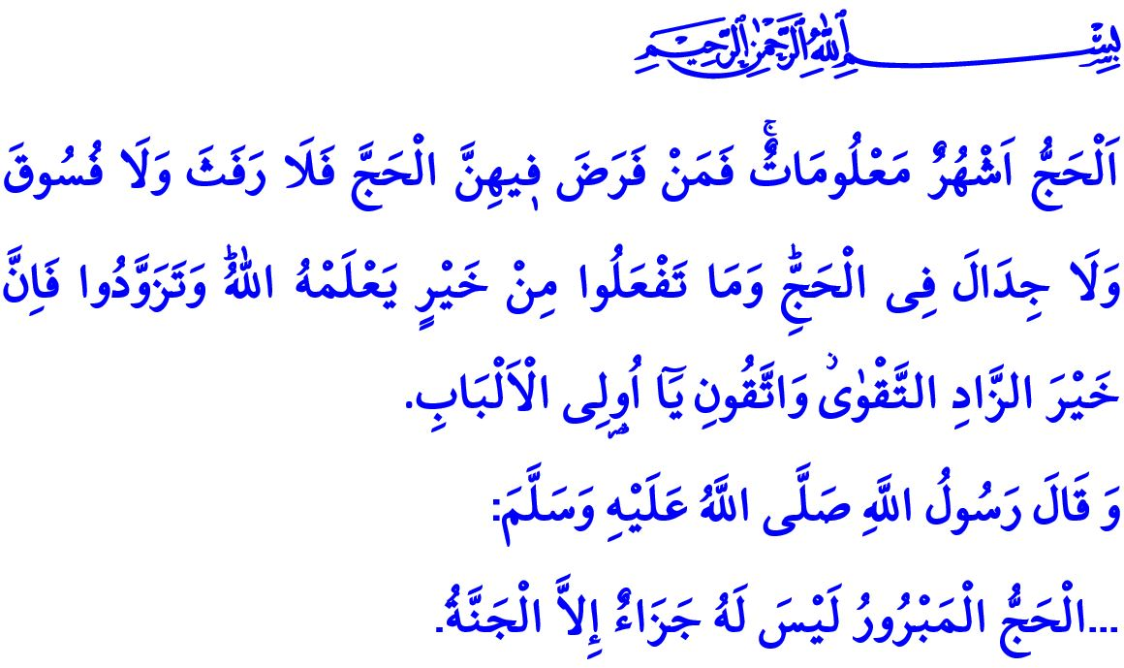
A SACRED JOURNEY: HAJJ
Honorable Believers!
The Almighty Allah (swt) states in the Holy Qur’an, “Surely the first House of worship established for humanity is the one in Makkah - a blessed sanctuary and a guide for all people. In it are clear signs and the standing place of Ibrahim. Whoever enters it should be safe. Pilgrimage to this House is an obligation by Allah upon whoever is able among people. And whoever disbelieves, then surely Allah is not in need of any of His creation.”
Dear Believers!
According to the Prophet Muhammad (saw), hajj is one of the five pillars on which Islam is established. Hajj means circumambulating the Ka’bah and standing (waqfah) at Arafat to gain Allah’s (swt) consent. It means the gathering of Muslims, after a sacred journey, in the shade of the Ka’bah towards which they turn for prayer all around the world other times. The Almighty Allah (swt) addresses those Muslims who set out to visit His House as follows: “The Hajj is in appointed months. Whoever commits to performing hajj, let them stay away from intimate relations, foul language, and arguments during the hajj. Whatever good you do, Allah fully knows of it. Take necessary provisions for the journey. Surely the best provision is righteousness (taqwa). O people of reason, be mindful of Me!”
Dear Muslims!
Muslims who commit to performing hajj and set off for it wears ihram, physically, and taqwa, spiritually. They promise to follow the commands of Allah (swt) and the Prophet Muhammad (saw), and stay away from any kind of sins, wrongdoings, and unpleasant acts. Together with their Muslim brothers and sisters of different skin colors, languages, and countries of origin, they pray reciting talbiyah,
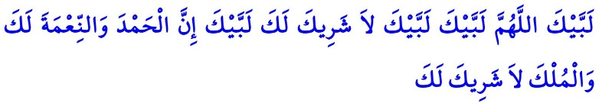 “Here I am, o Allah, here I am! I am obedient to Your commands! You have no partner. Here I am, o Allah! All praise is for you. All blessings and all sovereignty is yours. You have no partner.”
The Prophet Muhammad (saw) says, “The voice of a believer who recites talbiyah is accompanied by stones, trees, and even earth.” An amazing choir of universe prays along with prospective pilgrims.
Honorable Believers!
The glad tiding by the Prophet Muhammad (saw) is reciprocated in the hearts of Muslims in their every step during the hajj: “The reward of Hajj that is accepted by Allah is nothing but heaven.” Prospective pilgrims who want to be on the receiving end of this glad tiding climb to Mount Arafat, rehearsing the Day of Judgement. Arafat means to know the truth, reach wisdom, and account for oneself before death.
Pilgrims flood to Muzdalifah after the Arafat waqfah, and then to Mina. While Muzdalifah is where they stand for waqfah in the sight of Allah in order to gain awareness, Mina is where the expression of forsaking all the worldly blessings and asking for the consent of Allah only is manifested.
Muslims who stone the Devil at Jamarat actually stone their own selves, greeds, and passions that keep inviting them to committing sins. Then, they head to the Ka’bah for the tawaf al-ziyarah. Their eyes turn to the Ka’bah, their hearts to Allah (swt).
The animals sacrificed during the hajj are of the signs of Allah (swt). But neither their meat nor their blood reach Him. What is going to reach Him is our taqwa only.
Dear Muslims!
Hajj is literally a cornerstone for Muslims. Pilgrims manifest on themselves the Prophet Ibrahim’s loyalty, the Prophet Ismail’s submission, and Hajar’s reliance on Allah (swt). They express their willingness to sacrifice themselves for the sake of Allah (swt). Pilgrims who visits the places bearing the Prophet Muhammad’s (saw) footprints experience patience, gratefulness, revitalization, and tranquility all at the same time. Muslims who bring with them taqwa for their sacred journey should stay away any kind of bad words and acts in order not to waste their taqwa. Utmost care should be paid not to cause any damage to any living being and the nature during the performance of hajj. Pilgrims leaving from those sacred places by leaving behind all their past mistakes and sins should never repeat the same mistakes and sins in the remainder of their lives.
I would like to take this opportunity to pray that the Almighty Allah (swt) may accept the worships of hajj that members from among our community will perform. I would like to conclude this khutbah with the Prophet Muhammad’s (saw) following words: “Those who go on pilgrimage and umrah are the messengers of Allah (swt). If they pray to Allah, He accepts their prayers; and if they ask Allah to forgive their sins, He forgives their sins.”

Ali ‘Imran, 3/96-97.
Baqarah, 2/197.
Muslim, Hajj, 19,21.
Tirmidhi, Hajj, 14.
Bukhari, Umrah, 1.
Ibn Majah, Manasiq, 5. General Directorate of Religious Services

